Week 5-Employee Database

Create database 1BM21CS113_Employee;

use 1BM21CS113_Employee;

create table Dept

(

deptno int primary key,

dname varchar(30),

dloc varchar(40)

);

create table Employee

(

empno int primary key,

ename varchar(40),

mgr_no int,

hiredate date,

sal decimal,

deptno int,

foreign key(deptno) references Dept(deptno) on delete cascade on update cascade

);

create table Project

(

pno int primary key,

ploc varchar(40),

pname varchar(40)

);

create table Assigned_to

(

empno int,

pno int,

primary key(empno,pno),

foreign key(empno) references Employee(empno) on delete cascade on update cascade,

foreign key(pno) references Project(pno) on delete cascade on update cascade,

job_role varchar(30)

);

create table Incentives

(

empno int,

incentive_date date,

primary key(empno,incentive_date),

foreign key(empno) references Employee(empno) on delete cascade on update cascade,

incentive_amt decimal

);

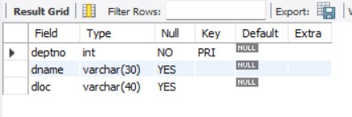desc Dept;

desc Employee;

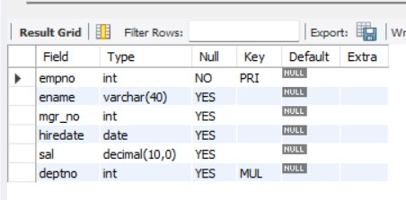

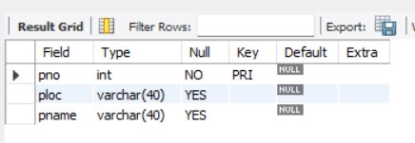desc Project;

desc Assigned_to;

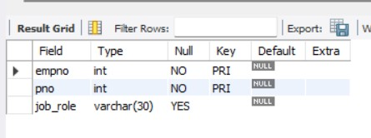

desc Incentives;

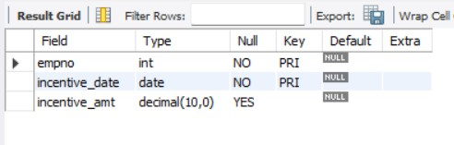

insert into Dept values(01,"Accounts","Banglore");

insert into Dept values(02,"HR","Banglore");

insert into Dept values(03,"Production","Hyderabad");

insert into Dept values(04,"Sales","Mysuru");

insert into Dept values(05,"Quality","Hyderabad");

insert into Dept values(06,"Marketing","Mysuru");

insert into Dept values(07,"RND","Banglore");

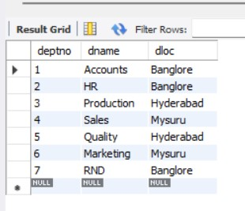select * from Dept;

insert into Employee values(10,"John","001","2017-04-12",50000,01);

insert into Employee values(11,"Bob","002","2018-05-11",40000,01);

insert into Employee values(12,"Kavita","003","2016-10-14",100000,02);

insert into Employee values(13,"Aliya","004","2015-04-16",55000,03);

insert into Employee values(14,"Ayan","005","2014-04-12",110000,02);

insert into Employee values(15,"Avinash","006","2014-09-20",60000,04);

insert into Employee values(16,"Aditi","007","2013-11-11",90000,07);

insert into Employee values(17,"Naina","008","2015-12-29",95000,07);

insert into Employee values(18,"Akshay","009","2014-07-22",55000,05);

insert into Employee values(19,"Karthik","010","2013-10-11",90000,06);

insert into Employee values(20,"Chetan","011","2015-05-02",99000,06);

insert into Employee values(21,"Raksha","012","2016-08-11",85000,04);

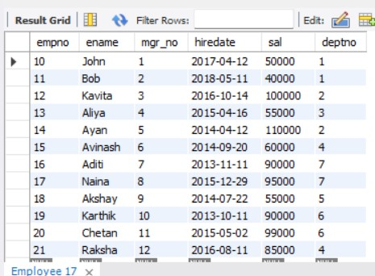select * from Employee;

insert into Project values(1,"Banglore","Satellite Mapping");

insert into Project values(2,"Delhi","E-commerce");

insert into Project values(3,"Mysuru","Mobile Development");

insert into Project values(4,"Hyderabad","Driverless cars");

insert into Project values(5,"Banglore","AI/ML");

insert into Project values(6,"Mumbai","Solar power plant");

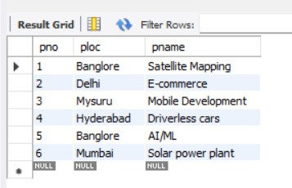select * from Project;

insert into Assigned_to values(10,1,"Manager");

insert into Assigned_to values(11,1,"Production head");

insert into Assigned_to values(12,5,"Financial Advisor");

insert into Assigned_to values(13,4,"Manager");

insert into Assigned_to values(14,5,"Manager");

insert into Assigned_to values(15,6,"Roof top head");

insert into Assigned_to values(16,6,"Assitant Manager");

insert into Assigned_to values(17,3,"Manager");

insert into Assigned_to values(18,3,"Financial Advisor");

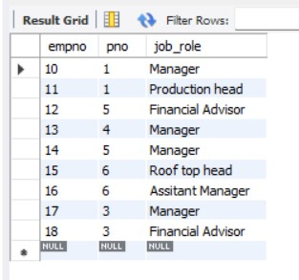select * from Assigned_to;

insert into Incentives values(11,"2020-12-13",12000);

insert into Incentives values(14,"2021-06-29",20000);

insert into Incentives values(15,"2021-09-13",13000);

insert into Incentives values(17,"2020-11-07",10000);

insert into Incentives values(10,"2021-01-09",20000);

insert into Incentives values(16,"2020-04-29",15000);

select * from Incentives;

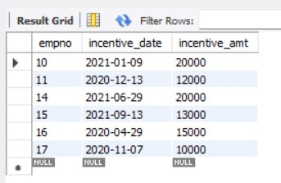

Queries:

1. select e.empno, e.ename

from Employee e,Project p,Assigned_to a

where e.empno=a.empno and

a.pno=p.pno and

p.ploc in("Banglore","Hyderabad","Mysuru");

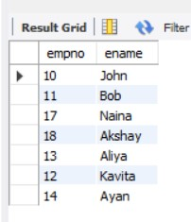

2. select empno

from Employee

where empno not in(select empno from Incentives);

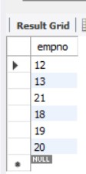

3. select e.ename,e.empno,d.dname,a.job_role,d.dloc,p.ploc

from Employee e, Dept d, Assigned_to a,Project p

where e.deptno=d.deptno and

a.empno=e.empno and

a.pno=p.pno and

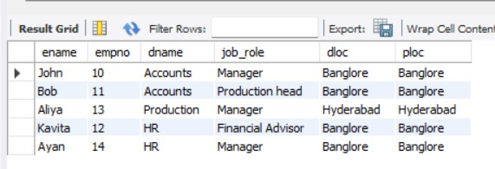 p.ploc=d.dloc;